Anthony Bugatto

EE 421: Digital Electronics

Project 2: Finite State Machine

November 29, 2018

For this project we created a Finite State Machine that recognized the 4 bit patterns: 0011, 1111, and 1001. In order to achieve this, I designed a Moore machine with 4 DFF and encoded 12 states to keep track of the data flow. The states are shown in figure 1, the state table is shown in figure 2, the truth table is shown in figure 3, and the state diagram is shown in figure 4.

|  |  |  |
| --- | --- | --- |
| State Names | Pattern | Output |
| A | 0 | 0 |
| B | 00 | 0 |
| C | 001 | 0 |
| D | 0011 | 1 |
| E | 1 | 0 |
| F | 10 | 0 |
| G | 100 | 0 |
| H | 1001 | 1 |
| I | 11 | 0 |
| J | 111 | 0 |
| K | 1111 | 1 |
| RESET | - | RST |

Figure 1: States and Encodings

|  |  |  |  |
| --- | --- | --- | --- |
| Present State: $$y_{3}y_{2}y_{1}y_{0}$$ | Next State: $Y_{3}Y_{2}Y_{1}Y_{0}$ | | Output:  z |
| w = 0 | w = 1 |
| RESET | A | E | 0 |
| A | B | A | 0 |
| B | A | C | 0 |
| C | F | D | 0 |
| D | F | J | 1 |
| E | F | I | 0 |
| F | G | E | 0 |
| G | B | H | 0 |
| H | F | D | 1 |
| I | F | J | 0 |
| J | F | K | 0 |
| K | F | K | 1 |

Figure 2: State Table

|  |  |  |  |
| --- | --- | --- | --- |
| Present State: $$y_{3}y_{2}y_{1}y_{0}$$ | Next State: $Y_{3}Y_{2}Y_{1}Y_{0}$ | | Output:  z |
| w = 0 | w = 1 |
| RESET | 0000 | 0100 | 0 |
| 0000 | 0001 | 0000 | 0 |
| 0001 | 0000 | 0010 | 0 |
| 0010 | 0101 | 0011 | 0 |
| 0011 | 0101 | 1001 | 1 |
| 0100 | 0101 | 1000 | 0 |
| 0101 | 0110 | 0100 | 0 |
| 0110 | 0001 | 0111 | 0 |
| 0111 | 0101 | 0011 | 1 |
| 1000 | 0101 | 1001 | 0 |
| 1001 | 0101 | 1010 | 0 |
| 1010 | 0101 | 1010 | 1 |

Figure 3: Truth Table

Figure 4: State Diagram

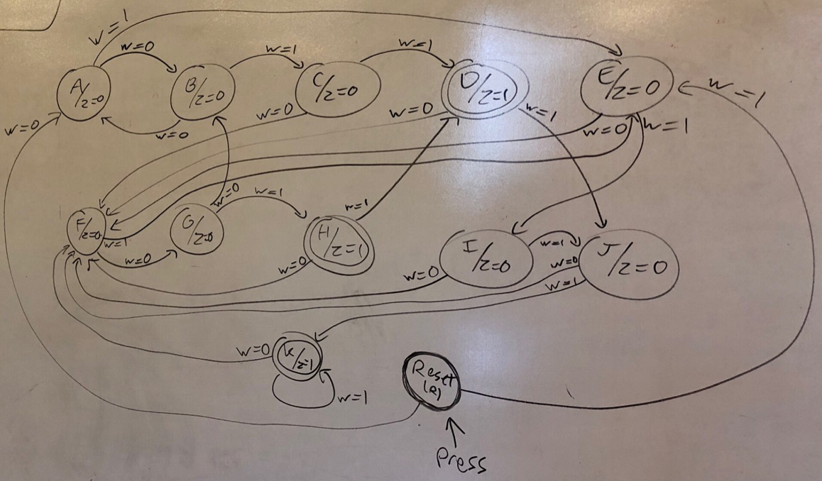

During testing the design was verified by working on the sequence in figure 5. The code is in Appendix A and the simulations are in Appendix B.

Figure 5: Verification Sequence



The schematic is shown in figure 6.

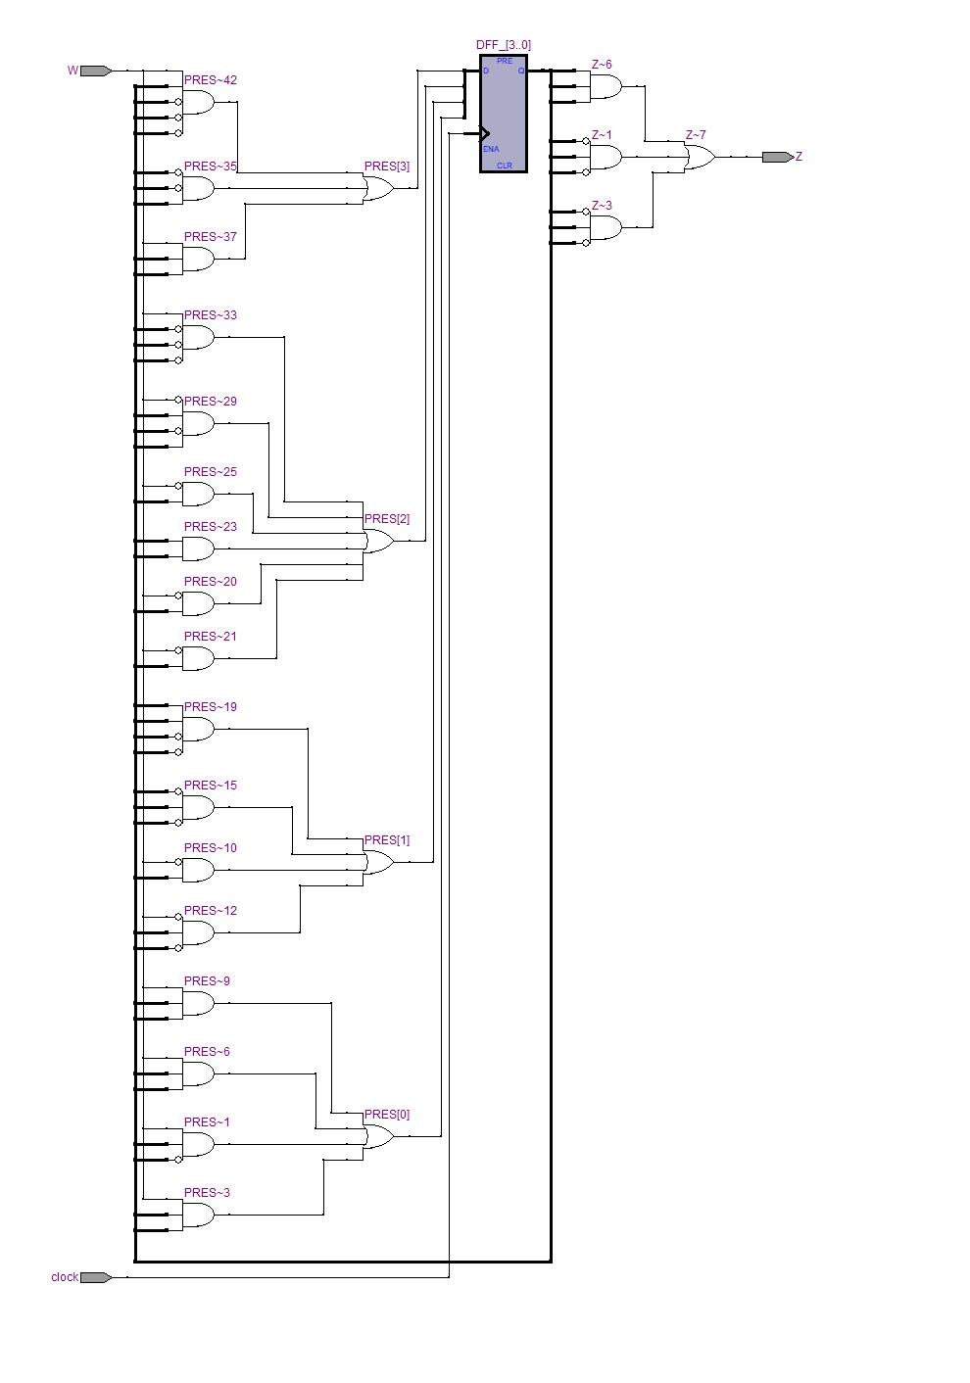

Figure 6: State Machine Schematic

**Appendix A: VHDL Code**

**Using Behavioral Design:**

LIBRARY IEEE;

USE IEEE.STD_LOGIC_1164.ALL;

USE work.FF_package.ALL;

ENTITY state_machine IS

PORT(

clock, reset, W : IN STD_LOGIC;

Z : OUT STD_LOGIC

);

END state_machine;

ARCHITECTURE behavioral OF state_machine IS

TYPE STATE_TYPE IS (A, B, C, D, E, F, G, H, I, J, K, R);

SIGNAL state : STATE_TYPE;

BEGIN

PROCESS(clock)

BEGIN

IF reset = '1' THEN

state <= R;

ELSIF clock'EVENT AND clock = '1' THEN --RISING EDGE

CASE state IS

WHEN R =>

IF W = '0' THEN

state <= A;

ELSE

state <= E;

END IF;

WHEN A =>

IF W = '0' THEN

state <= B;

ELSE

state <= A;

END IF;

WHEN B =>

IF W = '0' THEN

state <= A;

ELSE

state <= C;

END IF;

WHEN C =>

IF W = '0' THEN

state <= F;

ELSE

state <= D;

END IF;

WHEN D =>

IF W = '0' THEN

state <= F;

ELSE

state <= J;

END IF;

WHEN E =>

IF W = '0' THEN

state <= F;

ELSE

state <= I;

END IF;

WHEN F =>

IF W = '0' THEN

state <= G;

ELSE

state <= E;

END IF;

WHEN G =>

IF W = '0' THEN

state <= B;

ELSE

state <= H;

END IF;

WHEN H =>

IF W = '0' THEN

state <= F;

ELSE

state <= D;

END IF;

WHEN I =>

IF W = '0' THEN

state <= F;

ELSE

state <= J;

END IF;

WHEN J =>

IF W = '0' THEN

state <= F;

ELSE

state <= K;

END IF;

WHEN K =>

IF W = '0' THEN

state <= F;

ELSE

state <= K;

END IF;

END CASE;

END IF;

END PROCESS;

Z <= '1' WHEN state = D OR state = H OR state = K ELSE '0';

END behavioral;

**Using RTL Design:**

LIBRARY IEEE;

USE IEEE.STD_LOGIC_1164.ALL;

USE work.FF_package.ALL;

ENTITY state_machine IS

PORT(

clock, W : IN STD_LOGIC;

Z : OUT STD_LOGIC

);

END state_machine;

ARCHITECTURE structural OF state_machine IS

SIGNAL PRES : STD_LOGIC_VECTOR(3 DOWNTO 0); --Y

SIGNAL NXT : STD_LOGIC_VECTOR(3 DOWNTO 0); --y

BEGIN

-- Y(0) = y(1)y(2)'W + y(1)y(3)W + y(0)y(3)W + y(0)y(2)W

PRES(0) <= (NXT(1) AND NOT NXT(2) AND W) OR (NXT(1) AND NXT(3) AND W) OR (NXT(0) AND NXT(3) AND W) OR (NXT(0) AND NXT(2) AND W);

-- Y(1) = y(0)W' + y(1)y(2)'W' + y(1)y(2)y(3)' + y(0)y(2)'y(3)' + y(0)'y(1)'y(2)y(3)

PRES(1) <= (NXT(0) AND NOT W) OR (NXT(1) AND NOT NXT(2) AND NOT W) OR (NXT(0) AND NOT NXT(2) AND NOT NXT(3)) OR (NOT NXT(0) AND NOT NXT(1) AND NXT(2) AND NXT(3));

-- Y(2) = y(1)W' + y(3)W' + y(0)y(3) + y(0)W' + y(1)'y(2)y(3)'W + y(0)'y(2)'y(3)'W

PRES(2) <= (NXT(1) AND NOT W) OR (NXT(3) AND NOT W) OR (NXT(0) AND NXT(3)) OR (NXT(0) AND NOT W) OR (NOT NXT(1) AND NXT(2) AND NXT(3) AND NOT W)

OR (NOT NXT(0) AND NOT NXT(2) AND NOT NXT(3) AND W);

-- Y(3) = y(0)'y(2)y(3)' + y(0)y(2)W + y(0)'y(1)'y(3)'W' + y(0)'y(2)'y(3)W

PRES(3) <= (NOT NXT(0) AND NXT(2) AND NOT NXT(3)) OR (NXT(0) AND NXT(2) AND W) OR (NOT NXT(0) AND NOT NXT(1) AND NOT NXT(2) AND NXT(3) AND W);

DFF_0: DFF PORT MAP(clock, PRES(0), NXT(0));

DFF_1: DFF PORT MAP(clock, PRES(1), NXT(1));

DFF_2: DFF PORT MAP(clock, PRES(2), NXT(2));

DFF_3: DFF PORT MAP(clock, PRES(3), NXT(3));

-- Z = y(1)y(2)'y(3)' + y(0)y(2)'y(3)' + y(0)y(2)y(3)

Z <= (NXT(1) AND NOT NXT(2) AND NOT NXT(3)) OR (NXT(0) AND NOT NXT(2) AND NOT NXT(3)) OR (NXT(0) AND NXT(2) AND NXT(3));

END structural;

**DFF Package:**

LIBRARY IEEE;

USE IEEE.STD_LOGIC_1164.ALL;

ENTITY DFF IS

PORT(

CLK, D : IN STD_LOGIC;

Q : OUT STD_LOGIC

);

END DFF;

ARCHITECTURE behavior OF DFF IS

BEGIN

PROCESS(CLK)

BEGIN

IF CLK'EVENT AND CLK = '1' THEN --rising edge

Q <= D;

END IF;

END PROCESS;

END behavior;

--declare package

LIBRARY IEEE;

USE IEEE.STD_LOGIC_1164.ALL;

PACKAGE FF_package IS

COMPONENT DFF

PORT(

CLK, D : IN STD_LOGIC;

Q : OUT STD_LOGIC

);

END COMPONENT;

END FF_package;

**Appendix B: Simulation**

